ST. XAVIER'S COLLEGE

Maitighar, Kathmandu



**COMPUTER GRAPHICS**

**LAB ASSIGNMENT # 7**

**SUBMITTED BY:**

Anu Kadel

013BSCCSIT007

**SUBMITTED TO:**

|  |  |
| --- | --- |
| **Er. Anil Sah**  Lecturer, St. Xavier’s College |  |

**Date of Submission:** 1st September, 2015

**LAB ASSIGNMENT #7**

**STATEMENT:**

**WRITE A PROGRAM TO TRANSLATE, ROTATE AND SCALE THE IMAGE IN C++ BUILDER.**

**SOURCE CODE**

**For Translate:**

//---------------------------------------------------------------------------

#include <math.h>

#include <vcl\vcl.h>

#pragma hdrstop

#include "rotate.h"

//---------------------------------------------------------------------------

#pragma resource "*.dfm"

TForm1 *Form1;

//---------------------------------------------------------------------------

__fastcall TForm1::TForm1(TComponent* Owner)

: TForm(Owner)

{

}

//---------------------------------------------------------------------------

void __fastcall TForm1::TranslateClick(TObject *Sender)

{

int x=Image1->Width;

int y=Image1->Height;

int Tx=StrToInt(Edit1->Text);

int Ty=StrToInt(Edit2->Text);

for(int i=0; i<=x; i++)

{

for(int j=0; j<=y; j++)

{

int a=i+Tx;

int b=j+Ty;

Image2->Canvas->Pixels[a][b]=Image1->Canvas->Pixels[i][j];

}

}

}

//---------------------------------------------------------------------------

void __fastcall TForm1::ScaleClick(TObject *Sender)

{

int x=Image1->Width;

int y=Image1->Height;

int Sx=StrToInt(Edit1->Text);

int Sy=StrToInt(Edit2->Text);

for(int i=0; i<=x; i++)

{

for(int j=0; j<=y; j++)

{

int a=i*Sx;

int b=j*Sy;

Image2->Canvas->Pixels[a][b]=Image1->Canvas->Pixels[i][j];

}

}

}

//---------------------------------------------------------------------------

void __fastcall TForm1::RotateClick(TObject *Sender)

{

int x=Image1->Width;

int y=Image1->Height;

int deg=StrToInt(Edit3->Text);

float rad=deg/180.0*3.141592;

for(int i=0; i<=x; i++)

{

for(int j=0; j<=y; j++)

{

int a=(i*cos(rad)-j*sin(rad))+250;

int b=(j*cos(rad)+i*sin(rad))+200;

Image2->Canvas->Pixels[a][b]=Image1->Canvas->Pixels[i][j];

}

}

}

//----------------------------------------------------------

**OUTPUT:**

**FOR TRANSLATE**

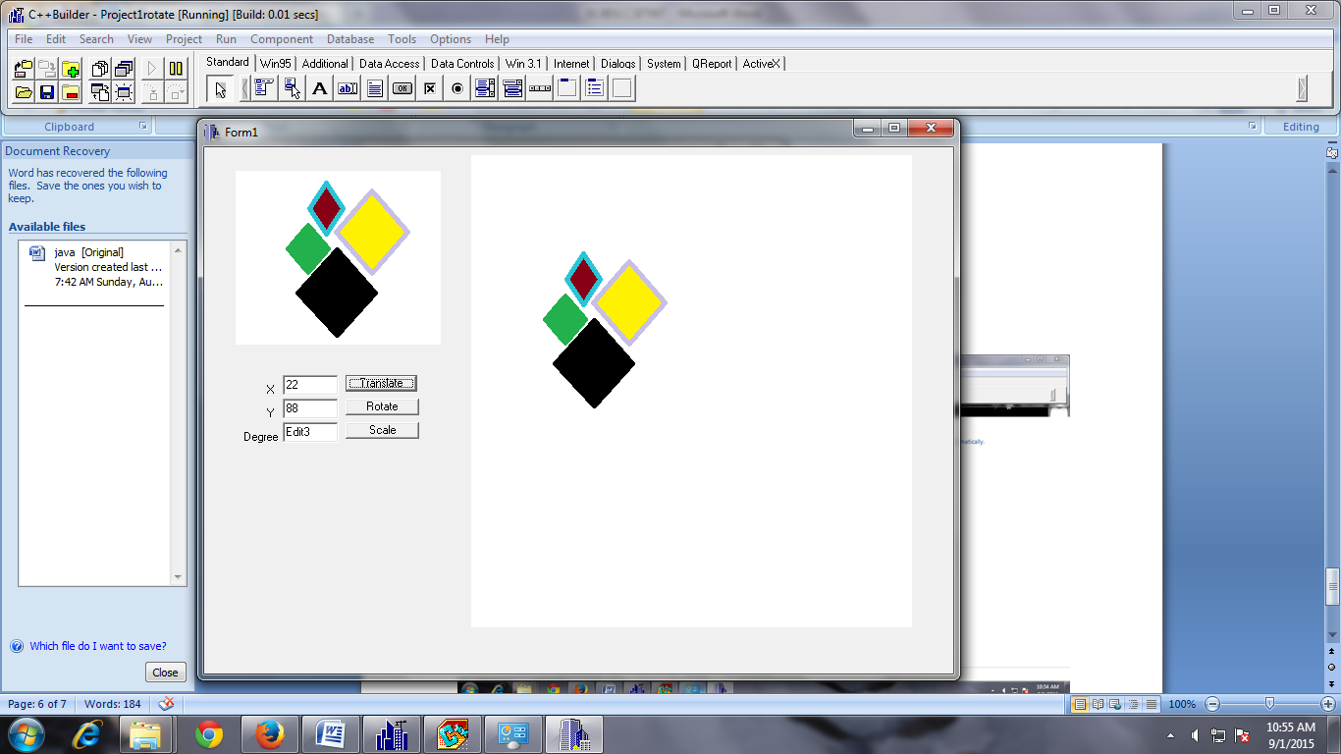

**FOR SCALE**

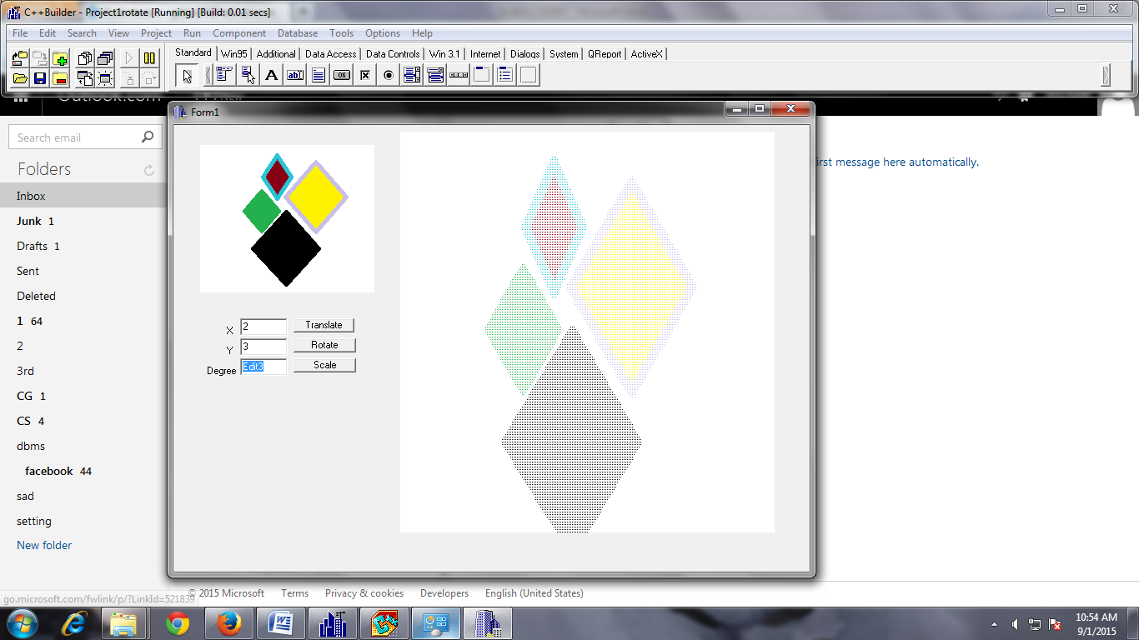

**FOR ROTATE**

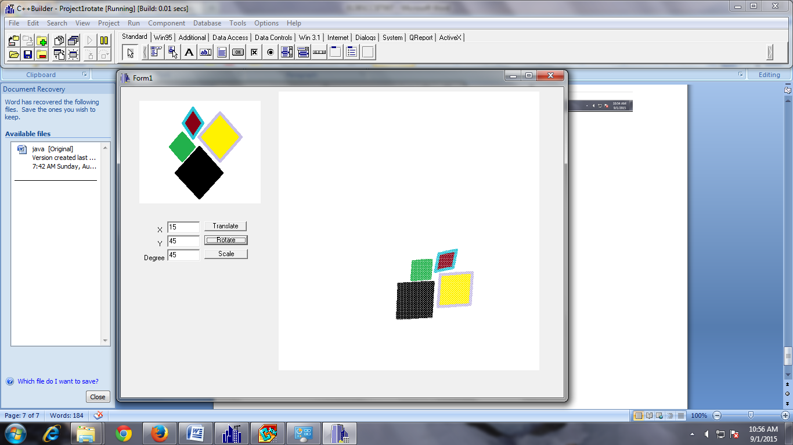

**CONCLUSION:**

Hence, the image was translated, rotated and scaled by using C++ Builder.